BSI KritisV Compliance for Log360
Ensure healthcare security and BSI KritisV compliance with Log360.
Region: Germany | Type: Critical Infrastructure, Healthcare, Operational Resilience | Category: Compliance | Pricing: Free

Overview
The BSI KritisV compliance extension in Log360 helps organizations meet BSI-KritisV, Germany's Critical Infrastructure Regulation mandating security requirements for operators across energy, water, healthcare, finance, and IT sectors under the BSI Act by providing centralized log management, real-time threat detection, and comprehensive audit trail generation. The platform supports BSI KritisV requirements for incident detection and BSI reporting, access control, privileged account oversight, network security, audit logging, vulnerability management, and business continuity monitoring.
For IT Security Incident Detection and BSI Reporting, Log360 provides real-time threat detection through correlated endpoint, network, and application log analysis, enabling timely identification of incidents requiring mandatory regulatory reporting. To address Access Control for Critical Systems, the platform monitors authentication events, failed logon attempts, and Active Directory access patterns across Windows, Unix, and network device environments. The extension also supports Privileged Account Oversight by providing capabilities that tracks administrative account modifications, user group changes, SUDO command usage, and password policy enforcement across critical system environments.

Key Features
- Network Security and Segmentation Monitoring: Log360 captures firewall policy changes, network device configuration modifications, attack attempts, and traffic anomalies across critical network segments.
- Audit Logging and Log Integrity: Log360 centralizes Windows event logs, process tracking records, policy change events, and GPO audit data to support regulatory examination and forensics.
- Threat-Led Vulnerability Management and Reporting Support: Log360 transforms raw scan data into actionable insights by mapping identified vulnerabilities against global threat intelligence, ensuring that security gaps in critical systems are prioritized and addressed in accordance with BSI security standards.
- Business Continuity and Data Integrity Monitoring: Log360 monitors backup job completion, disaster recovery infrastructure health, backup policy enforcement, and file integrity to detect threats to business continuity of critical infrastructure operators.

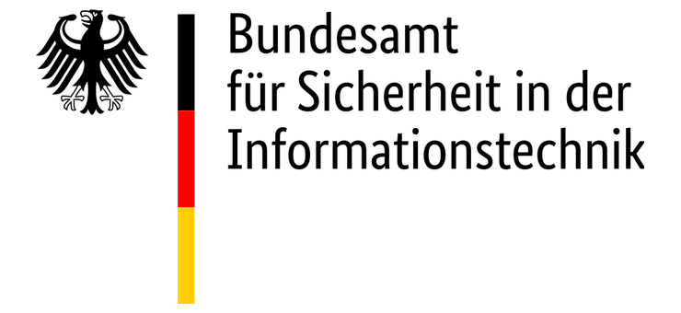
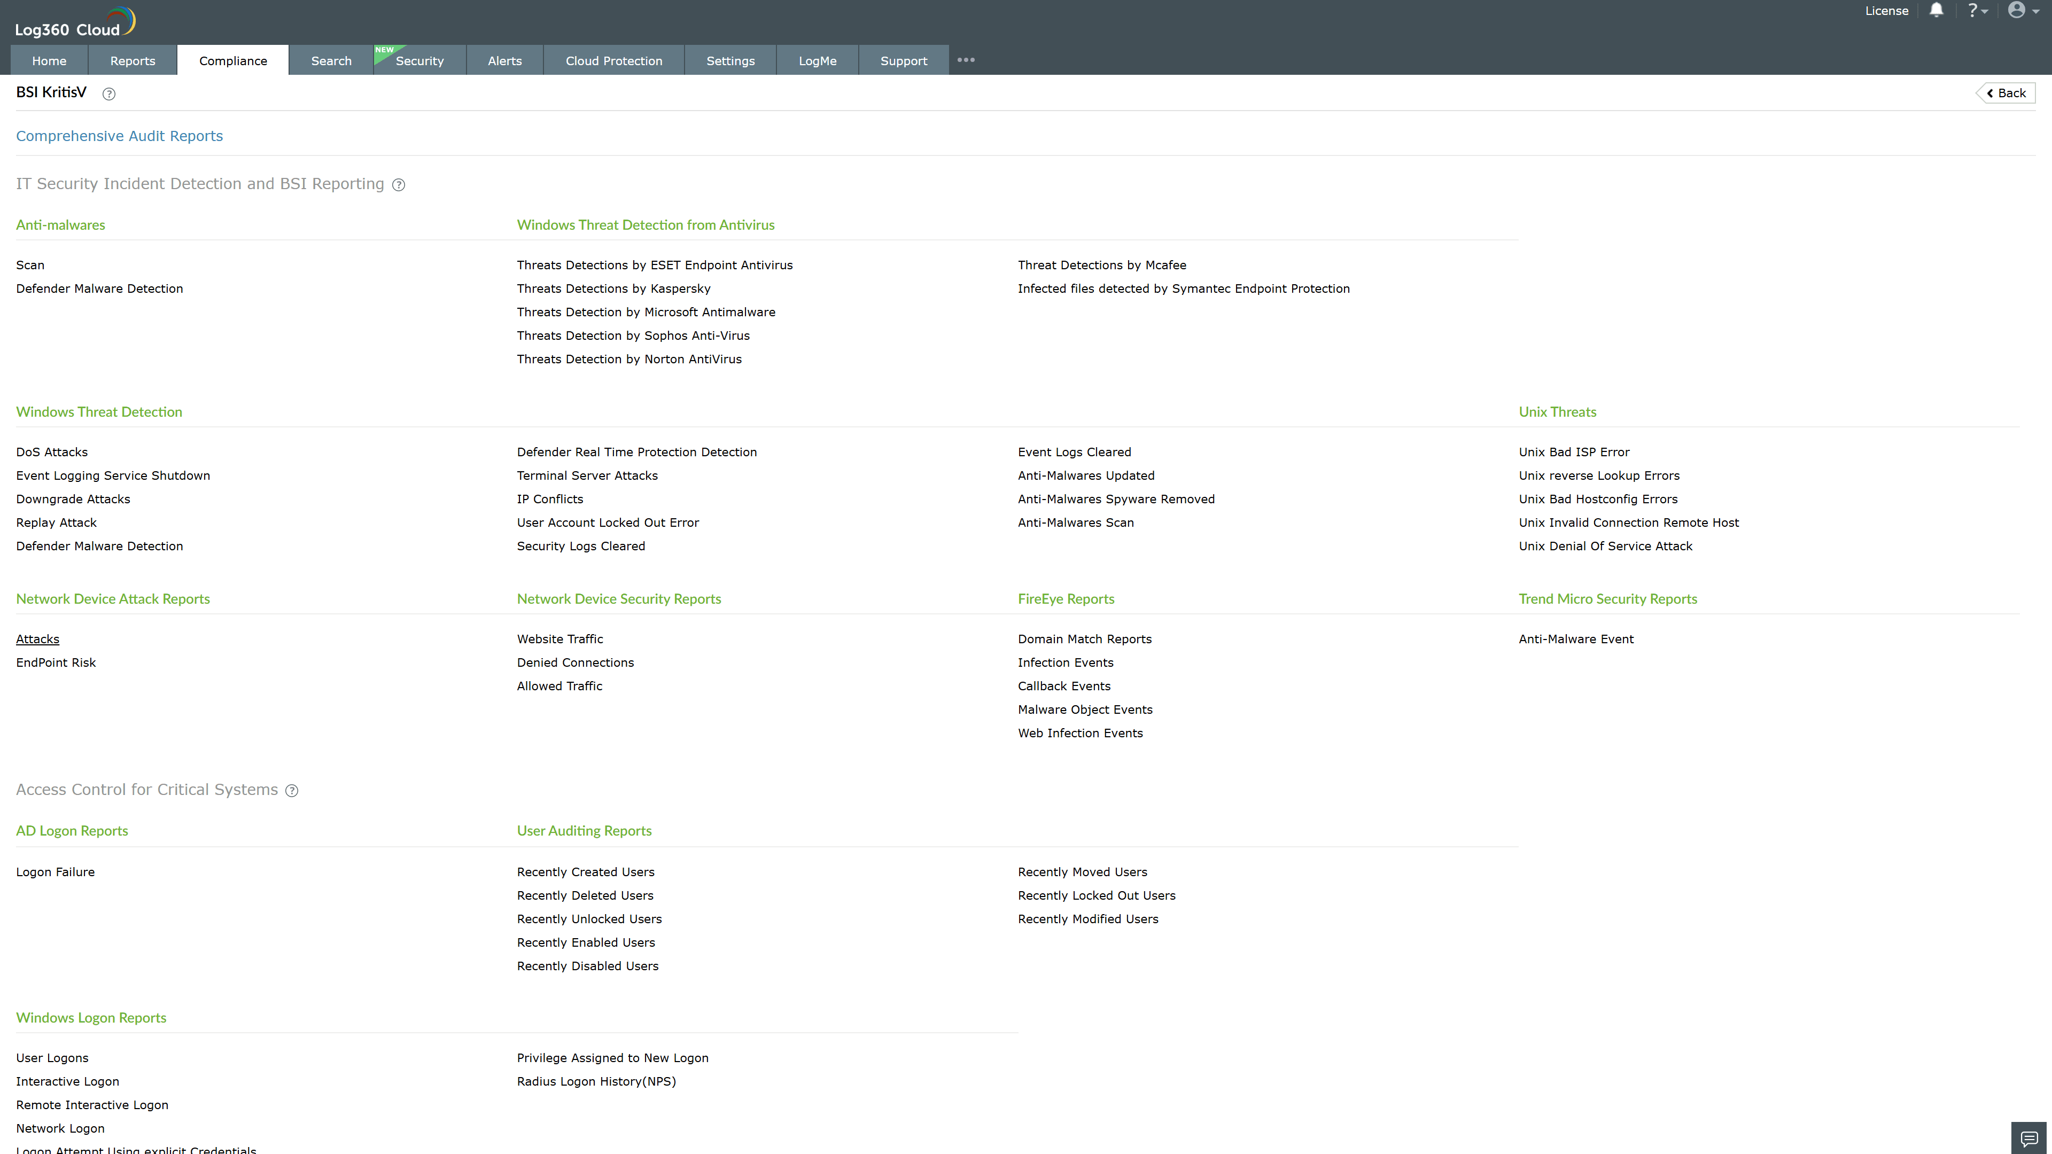
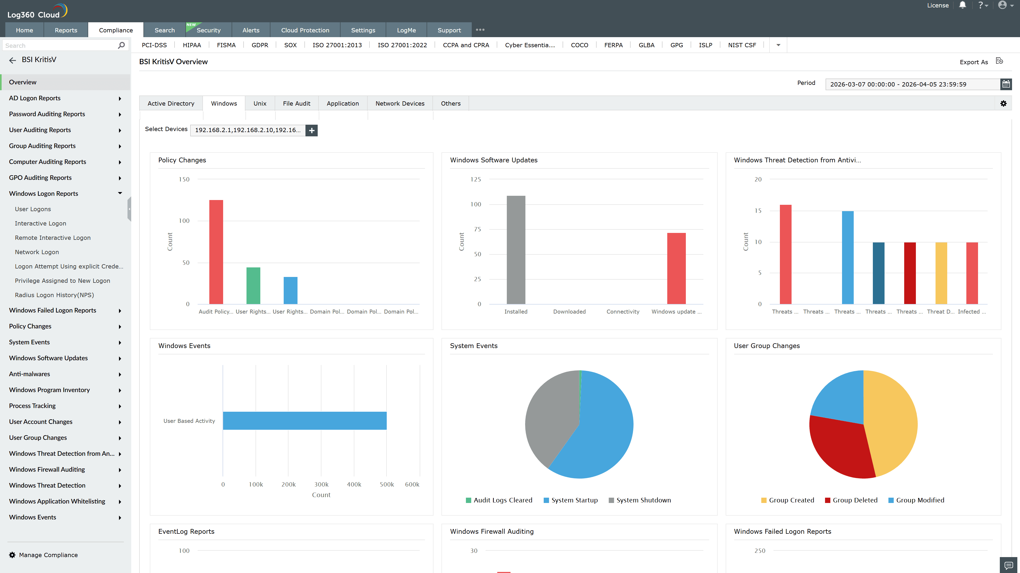
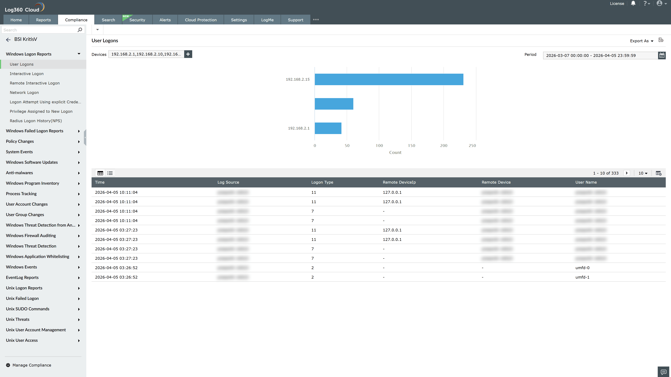
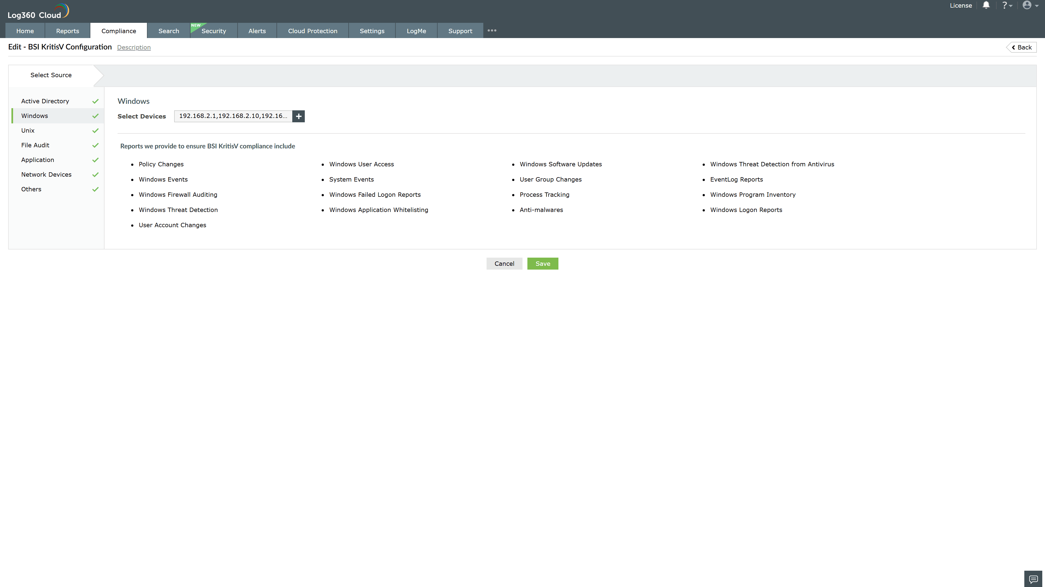
Valid Submission : Yes
Supported Editions : Free, Basic, Standard, Professional, MSSP
Help Document : https://www.manageengine.com/log-management/help/integrations/compliance-extensions.html
Help Video : Not provided
Tags : Log360, Compliance, Privacy monitoring, Data privacy, Regulatory compliance
Supported DCs : US, IN, JP, CA, AU, UK and EU
Privacy Policy:
Terms of Service:
Release Notes:
Predefined reports for the BSI KritisV.

